Citizenship, Economics and Society (Secondary 1-3)
“3-minute Concept” Animated Video Clips Series:
“Bullying”
Teaching Guidelines

1. Title of the animated video clip: “Bullying”
2. Duration of the animated video clip: Around 3 minutes
3. Related CES Module: Module 2.1 Overcoming Growth Challenges
4. Introduction of the animated video clip: The animated video clip was developed by the Personal, Social and Humanities Education Section, Curriculum Development Institute, Education Bureau. It uses daily examples and simple language to succinctly explain the concept of “Bullying”.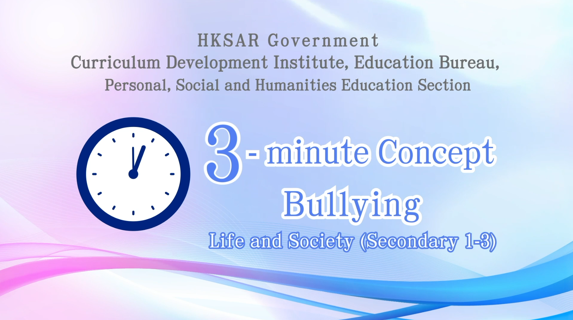
Citizenship, Economics and Society (Secondary 1-3)
Video link: https://emm.edcity.hk/media/Citizenship%2C+Economics+and+Society+%223-minute+Concept%22+Animated+Video+Clips+SeriesA+%2815%29+Bullying+%28English+subtitles+available%29/1_bc840hk2
5. Teaching tips: Teachers must explain the following main points to students after playing the “Bullying” animated video clip:
1) Build good interpersonal relationships and respect each other | Teachers should point out to students that building good interpersonal relationships is an important learning topic in the growth of adolescents. Adolescents should be sincere and friendly when getting along with peers, respect and care for others, learn to appreciate the strengths of others and understand their needs from each other’s perspective. Teachers can refer to the following resource:  Student Health Service - Health information - Psychosocial Health  https://www.studenthealth.gov.hk/english/health/health_ph/health_ph_lubf.html
2) Forms of bullying and the legal consequences of bullying | Teachers should point out to students that bullying is a serious aggressive behaviour. Bullying is not limited to physical violence; intimidating, name-calling, spreading rumours and isolating others are also considered bullying behaviours that can cause serious physical and psychological harm to the victims. Teachers can further point out to students that bullying behaviours such as assaulting, wounding, intimidating, blackmailing, criminal damage, etc., may be criminal offences and lead to legal consequences such as imprisonment. Even if the person is cheering, inciting and exerting group pressure on the target of bullying, there is still a risk of committing the criminal offence of aiding and abetting. Students must understand that Hong Kong society attaches great importance to values such as law-abiding and harmony and will not tolerate any form of bullying. Teachers can refer to the following resource:  The Government of the Hong Kong Special Administrative Region - LCQ6: Prevention of school and cyber bullying  https://www.info.gov.hk/gia/general/202305/24/P2023052400403.htm?fontSize=1
3) Ways to prevent cyber-bullying | Teachers should point out to students that some criminals use social networking to deliberately and repeatedly engage in hostile behaviours towards others. For example, harassing, “doxxing”, intimidating, slandering, threatening, spreading rumours or false information, etc., to damage others’ reputation or interpersonal relationships and cause repeated mental disturbances to the victims. Teachers should remind students to be vigilant when making friends on social media platforms and not to trust strangers easily or post personal information on websites, such as email addresses and photos. Teachers can refer to the following resource:  The Government of the Hong Kong Special Administrative Region “InfoSec” - Safe Online Social Networking  https://www.infosec.gov.hk/en/best-practices/person/safe-online-social-networking

6. Consolidation questions: (See next page)

“3-minute Concept” Animated Video Clips Series:

“Bullying”

Worksheet

A. Multiple Choice Questions
Circle the correct answers.
- Which of the following behaviours can be regarded as bullying?
  - call others an unkind name
  - mock or insult others because of his/her physical characteristics
  - isolate others on purpose
  - shove others on purpose

A. ii
B. i, ii
C. i, iii
D. i, ii, iii, iv
Ans: D

- Which of the following are elements involved in bullying?

  - the bully hurts another person on purpose
  - the bully is obviously more powerful than the victim
  - the act of bullying is repeated over a period of time
  - the act of bullying usually happens at night time

A. i,ii
B. ii, iii
C. i, ii, iii
D. i, iii, iv
Ans: C

- What are the different categories of bullying behaviours?

  - Physical bullying
  - Verbal bullying
  - Indirect bullying
  - Cyber-bullying

A. i, ii
B. ii, iii
C. i, ii, iii
D. i, ii, iii, iv
Ans: D

- When bullying happens or when we ourselves are being bullied, what should we do?

  - we should not join in so as to avoid encouraging the bullying behaviour
  - we should help the victim seek help
  - we should seek help from parents, teachers or social workers
  - we use physical force to fight back

A. i, ii
B. ii, iii
C. i, ii, iii
D. i, ii, iii, iv
Ans: C

B. Matching
Match the different roles in bullying with their behaviours correctly by drawing a line between them.

Roles |  | Behaviours
Bully |  | follows the bully and participates directly in bullying
Victim |  | comforts and supports the victim and tries to stop bullying
Assistant |  | starts the bullying behaviour
Defender |  | suffers from bullying
Reinforcer |  | stays out of the way, neither supports the bullying nor helps the victim
Bystander |  | supports the bullying behavior by teasing and cheering around

C. Short Question
When we come across cyber-bullying, how should we handle it?
- The best way to respond to those mean or abusive criticisms is not
to respond, making the bully feel uninterested.
- If the criticisms persist, we can ask the bully to stop at once. We
can report to the social media platform to bar the cyber-bully from
further posting messages. We can also request the social media
platform to delete the messages of the bully.
- We can also tell our trusted friends and adults, such as parents and
teachers to discuss ways to handle the bullying.
- Some extreme cyber-bullying may be legally liable. We can keep
the evidence to seek further help.

The End

